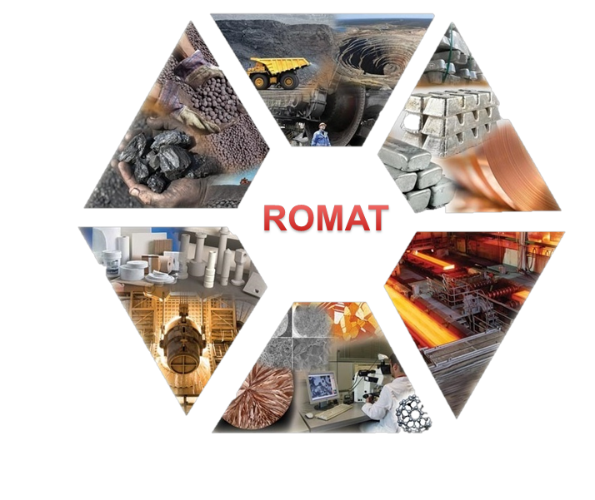

# REGISTRATION FORM

**10th International Conference on Materials Science and Technologies – RoMat 2024**

National University of Science and Technology Politehnica Bucharest (Romania)

November 14-15th, 2024

|  |  |  |  |  |  |
| --- | --- | --- | --- | --- | --- |
| **Name** |  | **Surname** | |  | |
| **Title** |  | | | | |
| **Affiliation** |  | | | | |
| **Phone** |  | **E-mail** | |  | |
| **Presentation**  **Title & Authors** |  | | | | |
| **Scientific Session** | 🞏 Advanced Materials for Industrial Application I (S1)  [robert.ciocoiu@upb.ro](mailto:robert.ciocoiu@upb.ro) | | | 🞏 Metallic Materials Obtainment Technologies (S2)  [onici.adrian@yahoo.ro](mailto:onici.adrian@yahoo.ro) | |
|  | 🞏 Materials Processing and Characterization (S3)  [nicoleta.zarnescu@upb.ro](mailto:nicoleta.zarnescu@upb.ro) | | | 🞏 Materials and Technologies for Defense Industry (S4)  [alinarobu2021@gmail.com](mailto:alinarobu2021@gmail.com) | |
|  | 🞏 Traditional and Digital Management and Engineering (S5)  [monica.iorga@upb.ro](mailto:monica.iorga@upb.ro) | | | 🞏 Surface Engineering, Coatings & Characterization Techniques I (S6)  [aura_catalina.mocanu@upb.ro](mailto:aura_catalina.mocanu@upb.ro) | |
|  | 🞏 Materials for Medicine: Medical Devices and Technologies (S7)  [anaiulia.bita@gmail.com](mailto:anaiulia.bita@gmail.com) | | | 🞏 Fire Protection Materials (S8)  [irina_varvara.anton@upb.ro](mailto:irina_varvara.anton@upb.ro) | |
| 🞏 Surface Engineering, Coatings & Characterization Techniques II (S9)  [elena.ungureanu1102@upb.ro](mailto:elena.ungureanu1102@upb.ro) | | | 🞏 Dental Biomaterials & Applications (S10)  [alina.necsulescu@upb.ro](mailto:alina.necsulescu@upb.ro) | |
| 🞏 Sustainability & Environmental Protection: Impact on Industry (S11)  [andrei.grecu931@yahoo.ro](mailto:andrei.grecu931@yahoo.ro) | | | 🞏 Advanced Materials for Industrial Application II (S12)  [vmarius_sim_pub@yahoo.com](mailto:vmarius_sim_pub@yahoo.com) | |
| **Presentation type** | 🞏 keynote | | 🞏 oral | | 🞏 poster |
| **Publication option** | 🞏 The Scientific Bulletin” Series B Chemistry and Materials Science | | | 🞏 Other ISI indexed journals with extra fees according the journal rules. | |

|  |
| --- |
| **Registration fees (200 euro / 1000 ron) will be the same for all participants, except the plenary invited speakers.**  Account details: Asociatia Stiintifica "Societatea Romana de Biomateriale"  **Euro**: RO69 RNCB 0077 0502 4793 0002  **Ron**: RO96 RNCB 0077 0502 4793 0001  Romanian Commercial Bank, Bucharest, 5, Regina Elisabeta Bvd, Postal Code 030016, Sector 3, SWIFT code: RNCBROBU. **Address**: street Gheorghe Polizu no.1, room DO12, registered at Romanian Commerce Register with no. 80-1 / 222296, CUI / C.I.F. 15318801; phone/fax 0213169563.  **Invoice Details:**  **…………………………………………………………………………………………………………….** |

***\*Registration form must be submitted together with abstract to the secretary of each conference topics and to*** [***diana.vranceanu@upb.ro***](mailto:diana.vranceanu@upb.ro) ***.***

**Date .....................**